**AUTOMATIC EMERGENCY LED LIGHT**

**ABSTRACT**

This automatic emergency led light used in night time when the power is cut or off by some reason. This emergency light takes 230V AC and it converts it in 12V DC and charge the battery which is used in this circuit. The power from the battery is used that time when the power is cut off or we need to use it.

In this circuit we use PNP transistor. The advantage of this emergency light is that if we use this light in a room with LED light source for high energy conversion efficiency. Re- chargeable batteries are NiCd or NIMh or LI-Ion type for getting high usable life.

**BLOCK DIAGRAM**

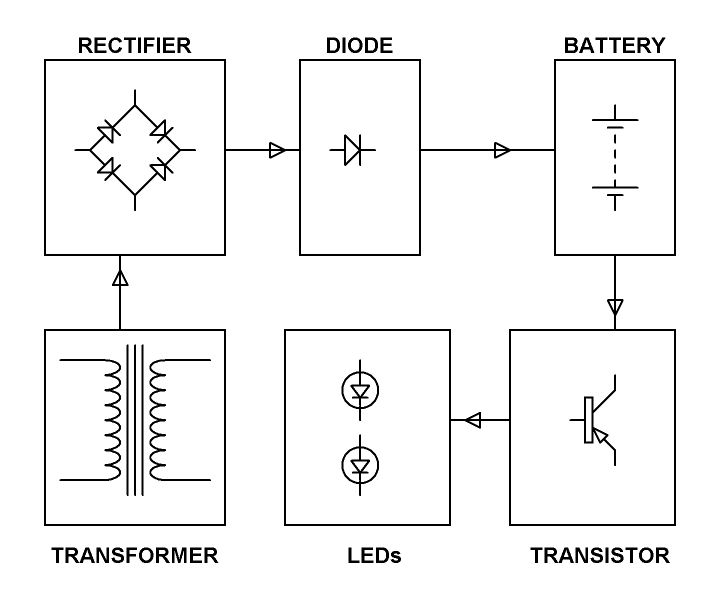

**HARDWARE REQUIREMENTS:**

1. Transformer
2. Rectifier
3. Ni-Cd battery
4. Transistor
5. LEDs
6. Diodes
7. Resistors
8. Capacitors